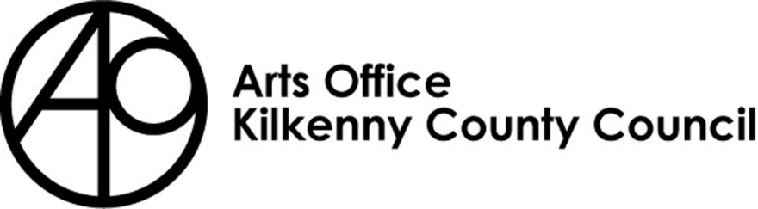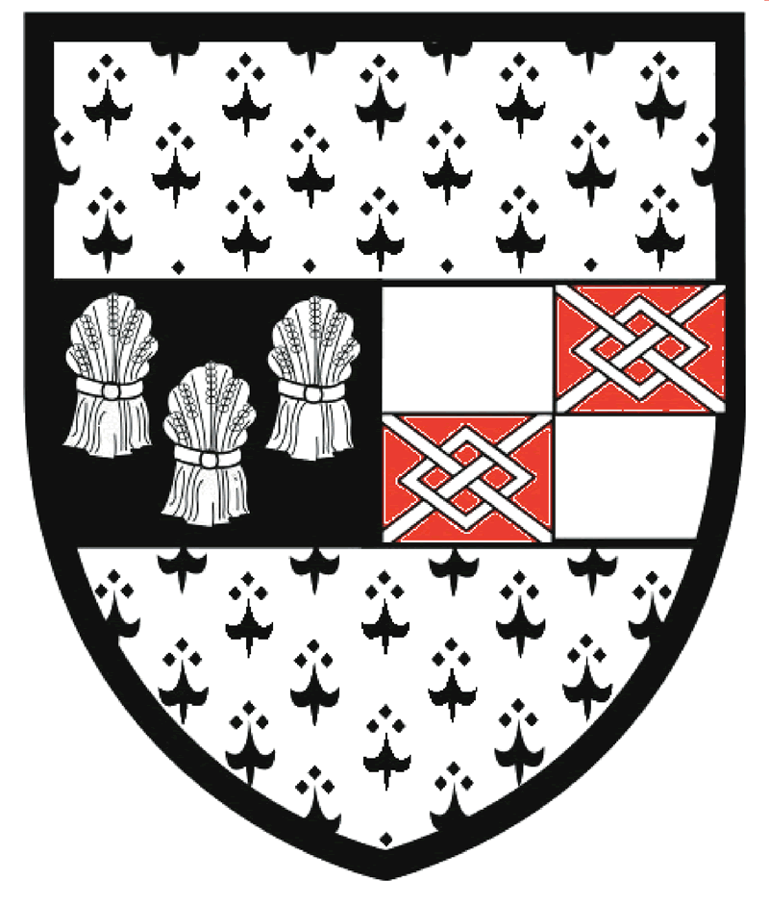

Kilkenny County Council Arts Office

Emerging Writer Residency Bursary 2021
(including play-writers and song-writers)

Return completed applications to:
Mary Butler, Arts Officer
Kilkenny County Council Arts Office,
Johns Green House, Johns Green, Kilkenny

Please mark envelopes:
‘The Moth Residency Bursary 2021’

Closing date is no later than 4pm Monday 18th January 2021.

The Moth Emerging Writer (including play-writers & song-writers) Residency Bursary 2021

Kilkenny County Council Arts Office in partnership with The Moth is offering a week-long residency at The Moth Retreat, Co. Cavan, to an emerging writer (including play-writers and song-writers) currently based in County Kilkenny. They will be selected based upon the information they send in their application and the project(s) they intend to undertake during their residency. Previous achievements may also be taken into consideration. The selected practitioner’s residency should take place within 12 months of receipt of their award.

Practitioners should apply by returning a completed application form (see below) an up to date C.V., samples of recent work and an outline of the project they intend to undertake at The Moth Retreat.

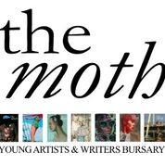

THE MOTH – WHO WE ARE

The Moth is home to the international art & literature magazine of the same name, and its junior counterpart The Caterpillar, as well as hosting several major literary and art prizes, including the €10,000 Ballymaloe International Poetry Prize.

The Moth magazine is, according to Donal Ryan, ‘an amazing magazine’. And he’s not the only one to have noticed. Former US Poet Laureate Billy Collins says, ‘There’s no other magazine like it,’ David Mitchell, the author of Cloud Atlas, described it as ‘a beautiful creature’, while Dermot Healy referred to it as ‘a rare literary gem.’

THE RETREAT

The directors of The Moth, Will Govan and Rebecca O’Connor, have lovingly restored an old barn next to their house and office in rural Cavan. The accommodation is over two floors, with a bedroom and bathroom upstairs and a living/studio space and kitchen diner downstairs.

They have created what they believe is the perfect environment in which artists and writers can work, away from the distractions of their everyday lives. The Moth is situated along a beautiful quiet country lane, surrounded by some of Cavan’s famous lakes. The nearest village of Milltown is 3 kilometres away. The accommodation is self-contained, but the directors of The Moth are on hand should the artist need anything. A bicycle is provided, and there is Wi-Fi, and Cavan Town is only 15 minutes away by car.

FURTHER INFORMATION

- This bursary is open to an emerging writer (including play-writers and song-writers) currently based in County Kilkenny

- Kilkenny County Council Arts Office reserves the right to not make a selection to award a bursary.

- Kilkenny County Council must be acknowledged on all publicity, press and marketing material, websites and social media outlets produced in connection with any subsequent undertakings or events relating to the residency. A copy of our logos will be provided by deirdre.southey@kilkennycoco.ie

- An evaluation report regarding your residency must be submitted to the Kilkenny County Council Arts Officer within one month of its completion. Failure to comply may result in future elimination for funding, grants of bursary from Kilkenny County Council Arts Office.

BURSARY APPLICATION FORM

Name:

___________________________________

- Contact address / details:

___________________________________________________________________________

___________________________________________________________________________

Telephone: _________________ Email: _____________________________________

Website / Blog / Social Media: ___________________________________________________________________________

Discipline Writer ⃝ Play-writer ⃝ Song-writer ⃝ Other ⃝

If other, please specify ______________________________________________________

- How long have you been resident in Kilkenny? _____________________________________

- Please provide your biography (200 words or less)

____________________________________________________________________________

____________________________________________________________________________

____________________________________________________________________________

____________________________________________________________________________

____________________________________________________________________________

____________________________________________________________________________

____________________________________________________________________________

____________________________________________________________________________

____________________________________________________________________________

____________________________________________________________________________

____________________________________________________________________________

____________________________________________________________________________

- Please include a statement about your work (200 words or less)

____________________________________________________________________________

____________________________________________________________________________

____________________________________________________________________________

____________________________________________________________________________

____________________________________________________________________________

____________________________________________________________________________

____________________________________________________________________________

____________________________________________________________________________

____________________________________________________________________________

____________________________________________________________________________

____________________________________________________________________________

____________________________________________________________________________

- Please describe the work you will undertake during your residency and how this will benefit your practice (200 words or less)

____________________________________________________________________________

____________________________________________________________________________

____________________________________________________________________________

____________________________________________________________________________

____________________________________________________________________________

____________________________________________________________________________

____________________________________________________________________________

____________________________________________________________________________

____________________________________________________________________________

____________________________________________________________________________

____________________________________________________________________________

____________________________________________________________________________

- List your most important publications, exhibitions or performances (if relevant) in the last 3 years:
____________________________________________________________________________

____________________________________________________________________________

____________________________________________________________________________

____________________________________________________________________________

- Please provide the names and contact details of two referees:
____________________________________ _______________________________________

____________________________________ _______________________________________

____________________________________ _______________________________________

____________________________________ _______________________________________

_____________________________________ ______________________________________

I consent to the collection and sharing of my contact information in relation to the processing of this Award and agree that it will not be used for any other purposes.
I confirm that I am over 18 years of age

Signed: ____________________________ Date: ___________________________

Remember!
- Please fill in all details. Failure to supply the information requested will result in the elimination of the application for consideration.
- Only typed applications or those completed clearly in block capital letters will be considered.
- The inclusion of any additional material must be clearly labelled with your name and contact details.
- Please attach a C.V. to your application form.
- Please enclose an s.a.e. for the safe return of your application and / or any materials sent to complement your application if you require it to be returned. If you do not include an s.a.e. we will assume that you do not need the material returned.
- Supporting information and Application Forms are available in large print on request.
- Incomplete applications will not be considered.
- Allow sufficient time for completion and delivery of application before the closing date.
- No electronic applications will be accepted; hard copies only.

Completed applications to be returned to:
Mary Butler, Arts Officer, Kilkenny County Council Arts Office, Johns Green House, Johns Green, Kilkenny.

Closing date is no later than 4pm on Monday 18th January 2021.
Please mark your envelope clearly as ‘The Moth Residency Bursary 2021’

